**7-3 Assignment: Project Two Submission**

Kiera P. Watts

Southern New Hampshire University

CS-255: System Analysis and Design

Professor David Randolph

February 23rd, 2025

## **UML Diagrams**

### **UML Use Case Diagram**

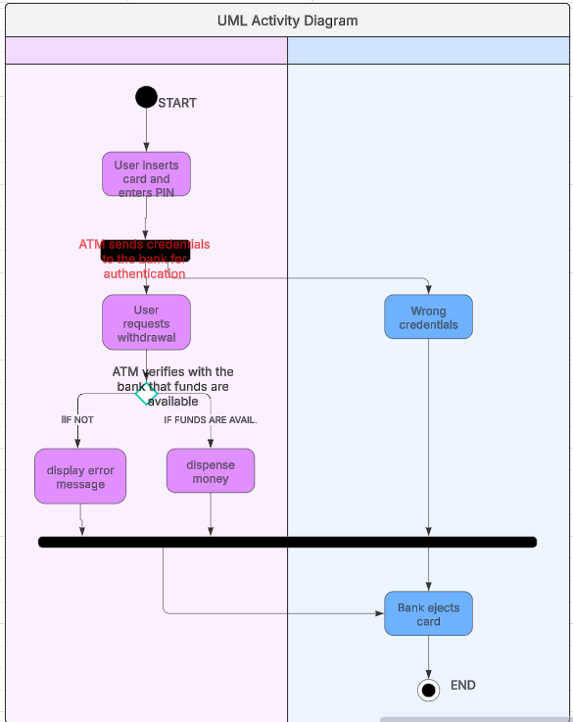

### **UML Activity Diagrams**

## **Scheduling a Driving Lesson**

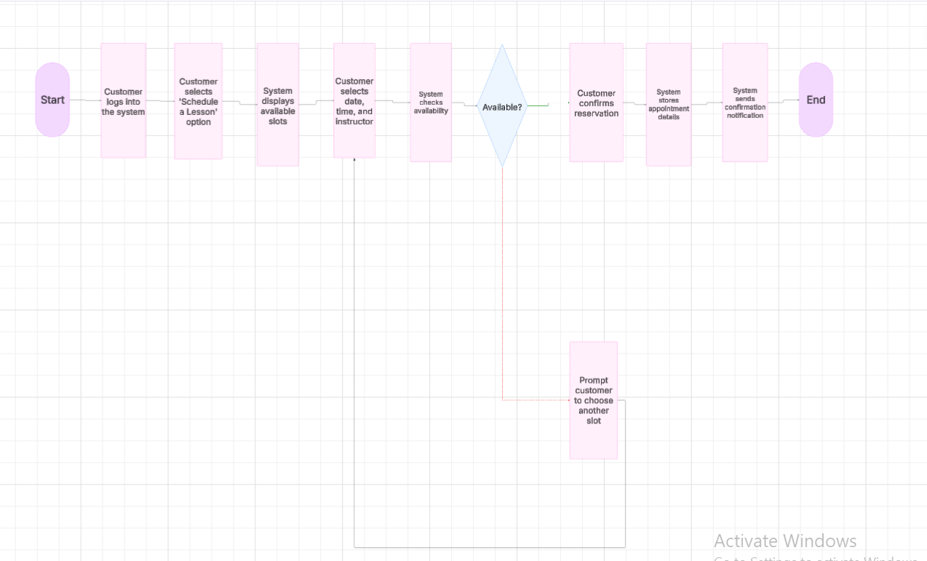

## **Resetting a Forgotten Password**

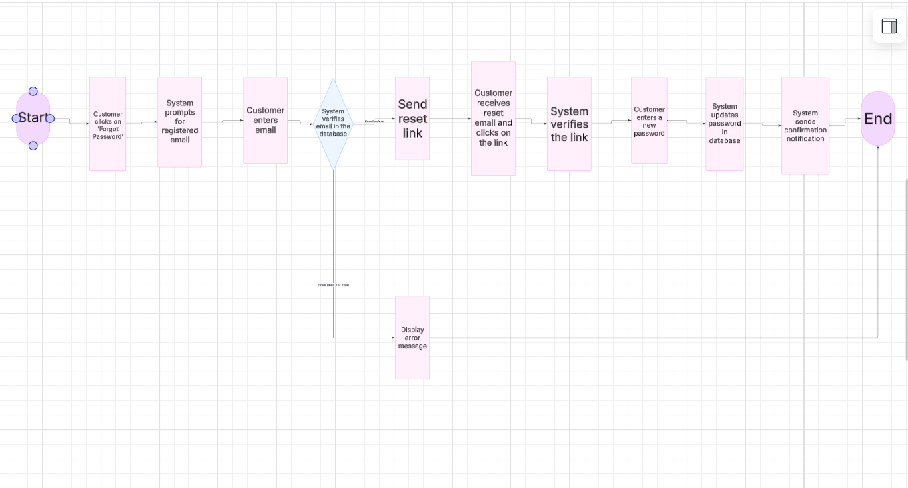

### **UML Sequence Diagram**

## **Scheduling a Driving Lesson**

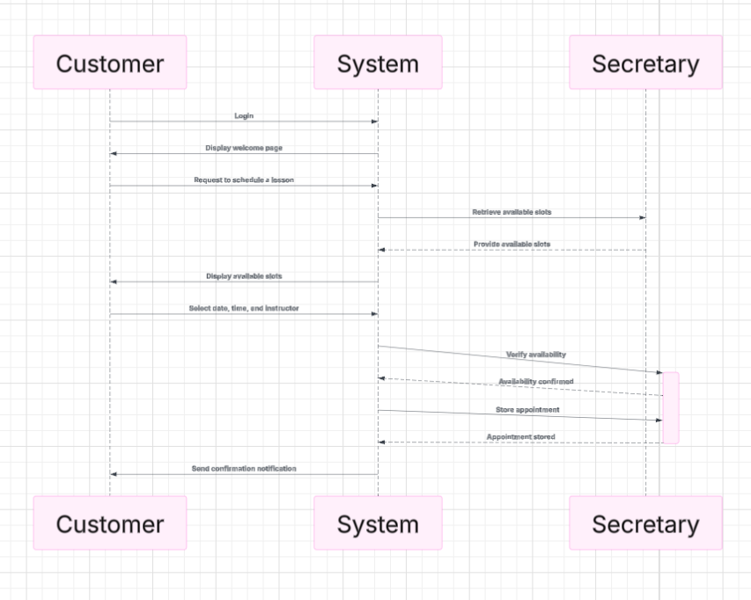

### **UML Class Diagram**

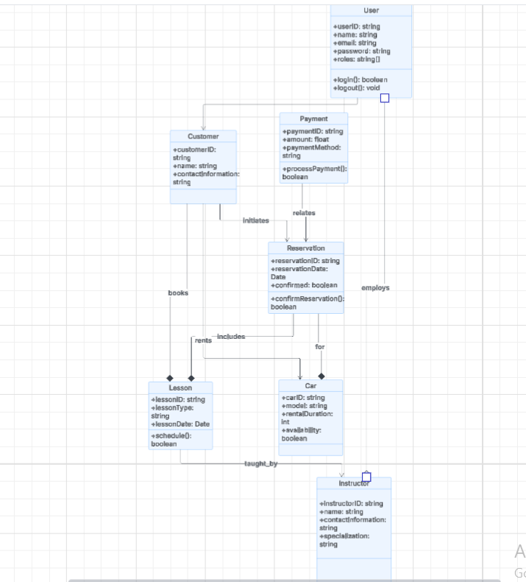

## **Technical Requirements**

With my system design, the hardware needed will include Cloud-based servers, secure data storage, client devices such as PCs, tablets, mobile phones. The software needed includes Web-based applications, database management systems and cloud hosting platforms such as AWS, Azure, or Google Cloud. The tools i used include Lucidchart for the required diagrams needed and the infrastructure needed includes a secure authentication system, role-based access control and automatic backup solutions.